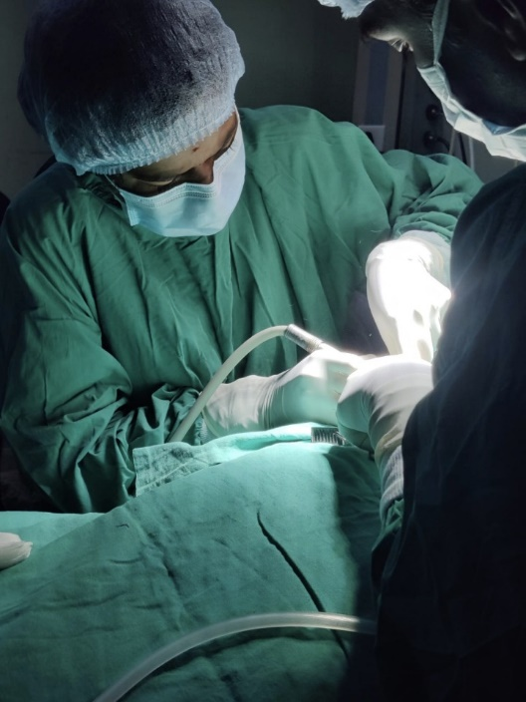
TREATMENT UNDER GENERAL ANESTHESIA
Paediatric general anaesthesia ensures that young patients remain pain-free and still throughout the operation.

TREATMENT UNDER CONSCIOUS SEDATION
Under the gentle effects of nitrous oxide, children can face dental treatments with a sense of calm and ease. This 'laughing gas' gives them a stress-free journey, and recovery is swift, leaving little ones ready to smile again in no time.

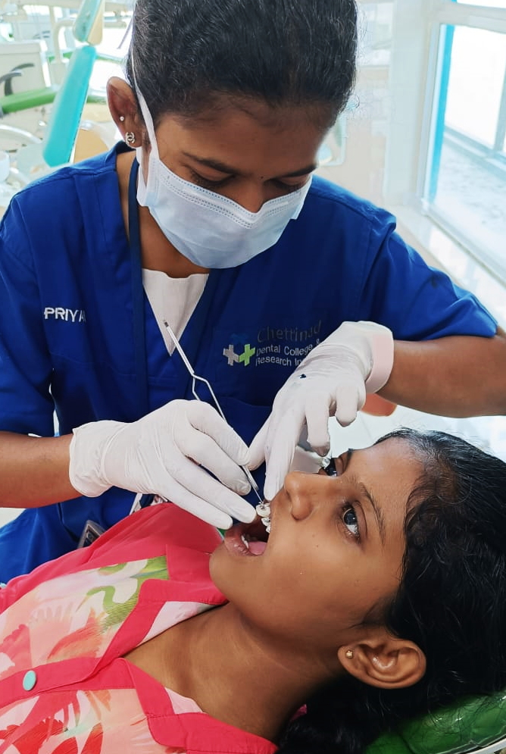
COMPREHENSIVE DENTAL TREATMENT
Comprehensive paediatric dental care, integrating orthodontics, myofunctional therapy, and endodontics, paves the way for a lifetime of healthy smiles. This holistic approach ensures each child's dental development is guided with precision, promoting both functional and aesthetic excellence.

FLOWABLE GUTTA PERCHA
Flowable gutta percha transforms root canal treatments, offering enhanced precision and adaptability over traditional methods. Its ease of application ensures a better seal, promising improved outcomes and long-term dental health.

PEADIATRIC MICROENDODONTICS
Micro endodontics in pediatric dentistry revolutionizes root canal treatments with unparalleled precision. By utilizing advanced magnification and technology, this approach ensures meticulous care, preserving young smiles with exceptional accuracy and effectiveness.

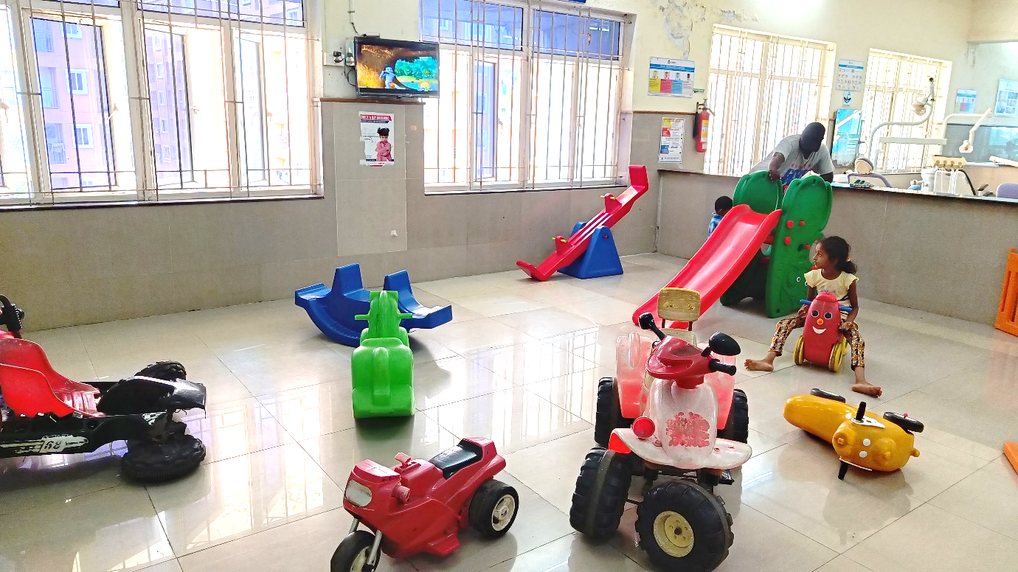
PLAY AREA

